**2024 Results are in!**

This year’s judges were Natalie Turner (Class 1+2) and Rob Eavis (Class 3)

Champion: Normannsson Baldr

Reserve Champion: Escrigg Phiggy

**Class 1 – Ram**

1st – Normannsson Flock with Normannson Baldr

2nd – Inchmore Flock with Kindrochaid Ferrero

3rd – Normannsson Flock with Normannson Bongull

1st – Normannson Baldr

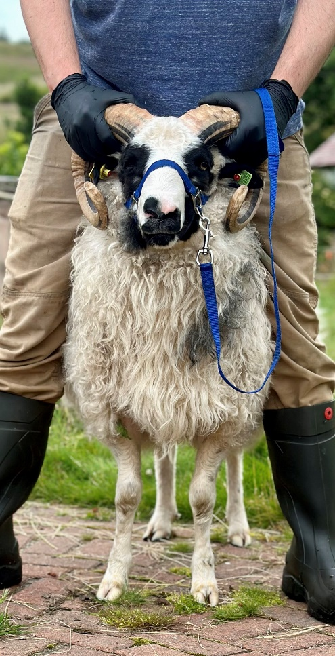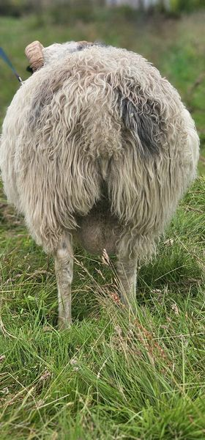

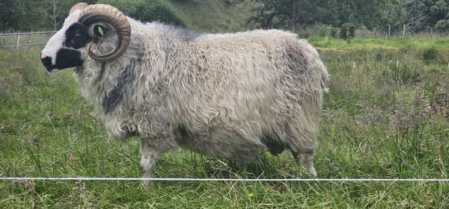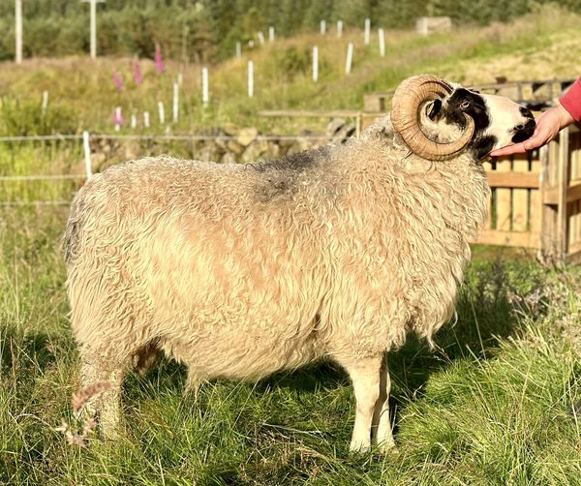

2nd - Kindrochaid Ferrero

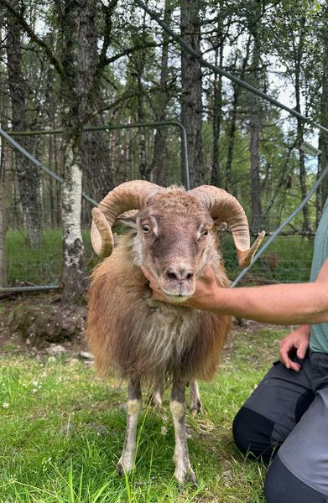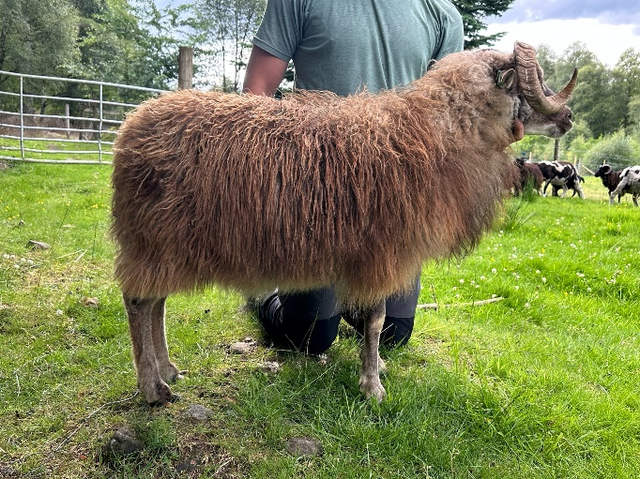

3rd – Normannson Bongull

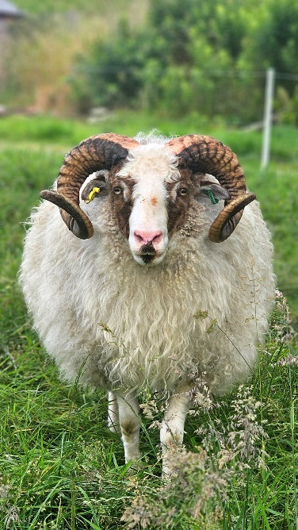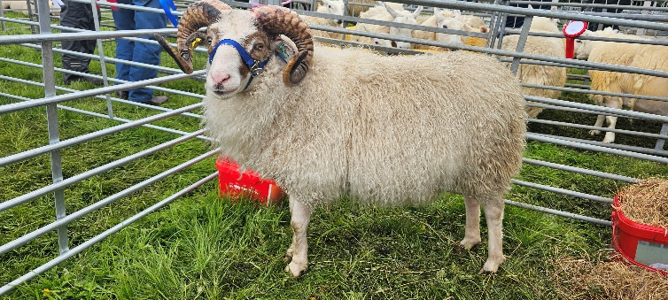

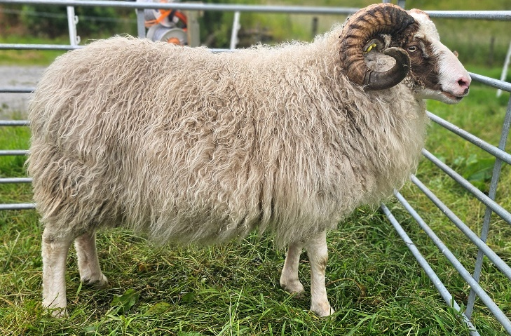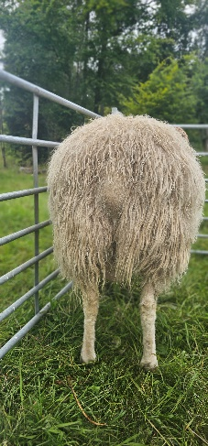

**Class 2 – Ewe**

1st – Escrigg Flock with Escrigg Phiggy

2nd – Letham Flock with Letham Oberry

3rd – Normannsson Flock with Old Hills Specs

1st – Escrigg Phiggy

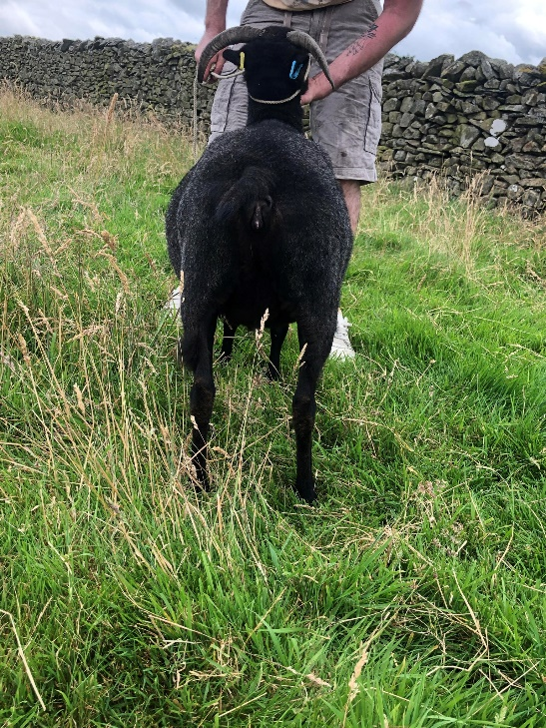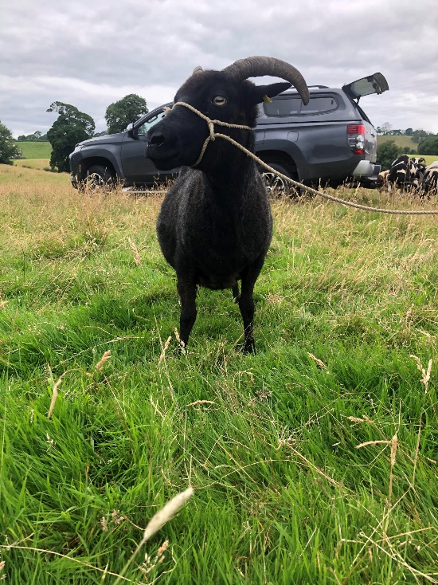

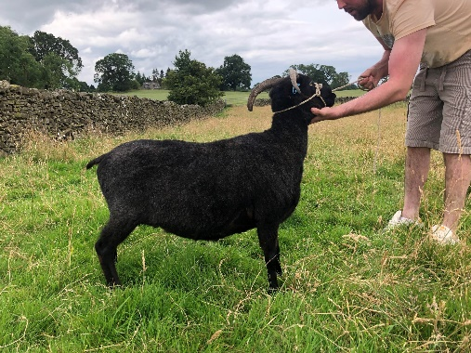

2nd – Letham Oberry

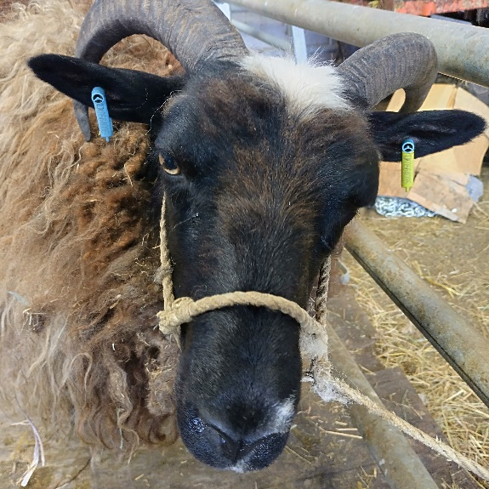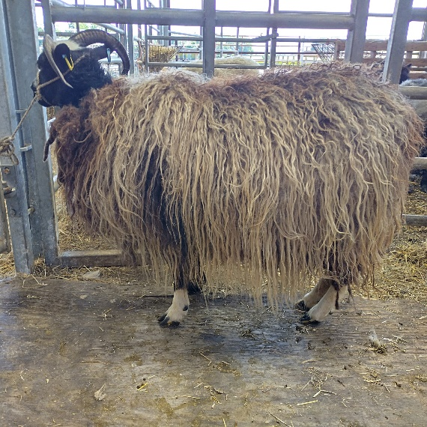

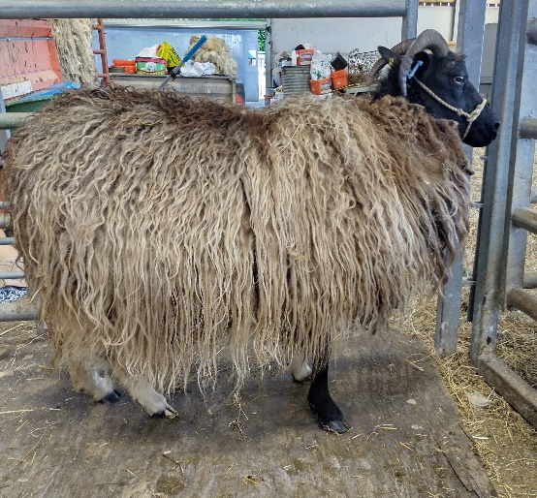

3rd – Normannson Astrid

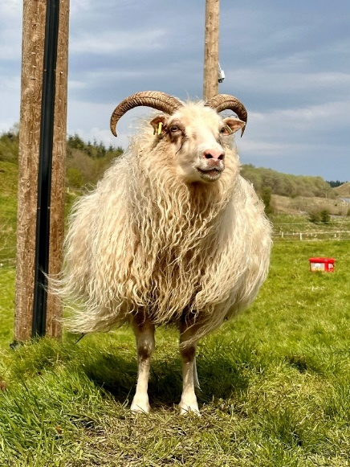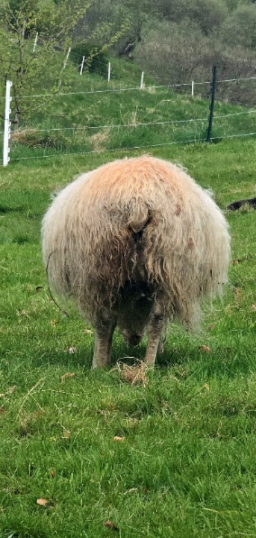

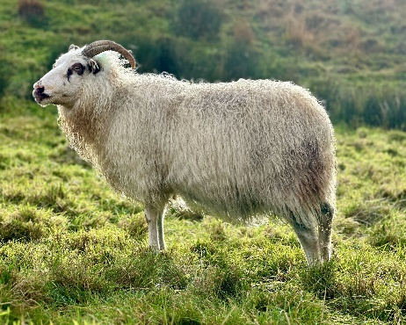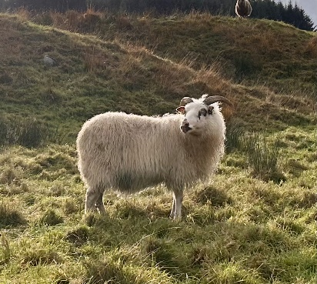

**Class 3 – General**

1st – Normannson Flock – portrait of Normannson Astrid

2nd – Assynt Flock

3rd – Artus Flock – Sunbed featuring Hravn Ástdís

As for feedback, Mr Eavis said, "These three photos stood quite far above the rest. Many of the others struggled with composition, lighting and engagement. Whereas the winning images succeeded with all three elements"

